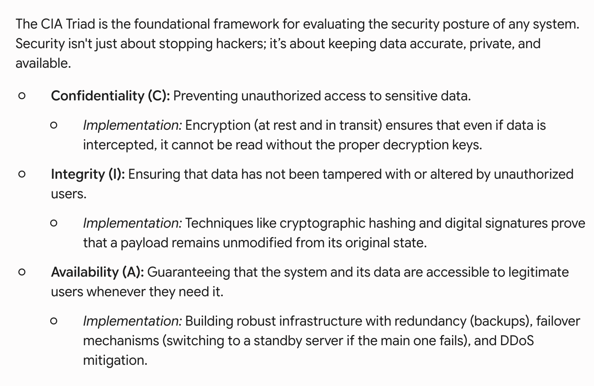
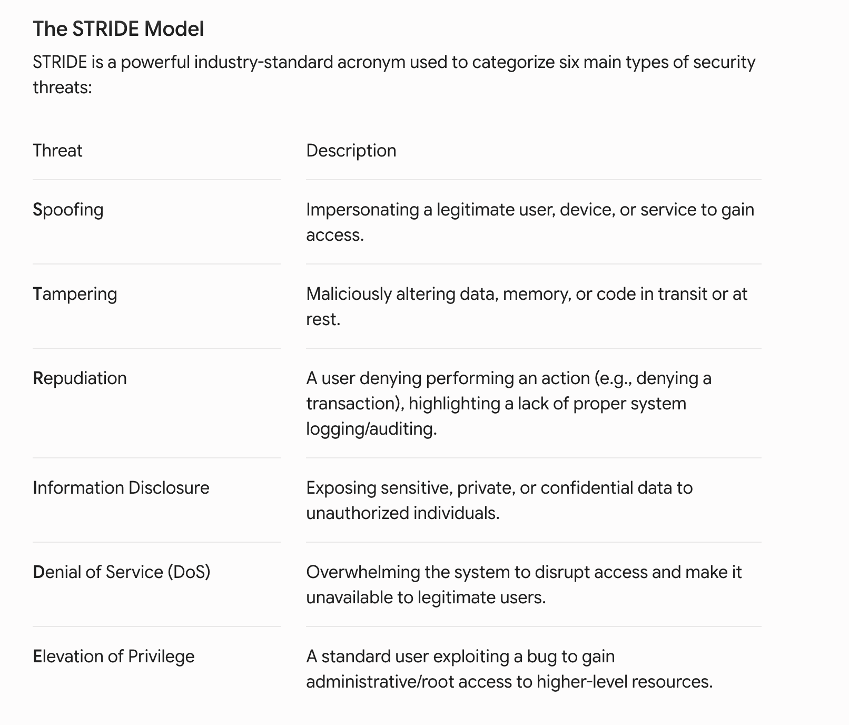
Attack Type | How it Works | Primary Target | Mitigation Strategies
DDoS (Distributed Denial of Service) | Floods the system with massive, fake internet traffic to overwhelm servers. | Availability | Rate limiting, traffic filtering, and failover/load distribution strategies.
Man-in-the-Middle (MitM) | Attacker secretly intercepts and alters communication between two parties. | Confidentiality & Integrity | HTTPS/TLS encryption, certificate pinning, and routing traffic through secure VPNs.
SQL Injection (SQLi) | Attacker submits malicious SQL code via user input fields to read or destroy database contents. | Confidentiality & Integrity | Strict input validation, parameterized database queries (prepared statements), and Web Application Firewalls (WAF).
Spoofing | Faking an IP address, email, or DNS to bypass authentication or steal traffic. | Access / Trust | Multi-Factor Authentication (MFA), token-based auth (JWT), and IP whitelisting.

